Trevor Johnson

MAE 598

Dr. Yi Ren

Project 2: Brake Design Optimization

# Introduction

Project 2 is about applying the optimization methods we have learned in class to a design problem. For this project, a rotary break was design and optimized to reduce the volume of the break while maintaining a high natural frequency, and safe operating max temperatures and stress. The optimization was done in ANSYS which has a built in optimization module. This feature utilizes parameters that can change the geometry of the design. The updated design is then solved with the finite element analysis modules. A response surface is created with the simulation runs conducted and this surface is used to optimize for the best design using the method of choice.

# Method and Results

For this project, about 115 different configurations were tested to create and refine the response surface. A genetic algorithm optimization and surface generation were used. These methods allow for multiple objectives to be simultaneously evaluated and optimized together. The three driving parameters are the thickness, inner diameter, and outer diameter of the rotor. Figure 1 shows the sketch used to revolve the rotor. The three yellow highlighted dimensions are the three parameters which are varied. V30 represents the inner diameter, V29 is the outer diameter, and H28 is the thickness.

Figure : Sketch for revolved entity to create the rotor

The rotor is made of cast iron while the brake pads are made of steel. These materials are both defined within ANSYS and do not need additional material property definitions for the simulations.

With the parameters determined, A static structural analysis is done. The setup has a rotating disk with a 250rad/s speed, and a brake caliper clamping pressure of 10.495 MPa. The brake pads are assumed to have a friction coefficient of 0.22. This analysis gives the maximum equivalent Von-Mises stress in the break. This is one of the objectives needed for the optimization. This module also calculated the volume of the brake which is the primary optimization variable.

A second analysis is done in the modal analysis module. This module computes the modes and frequencies of natural frequencies of the brake. This module suppresses the break calipers from the analysis and only focuses on the rotor. The 7th mode for oscillation is assessed to ensure the brake does not have a natural frequency close to the operating frequency of the engine. The goal is to have a very high frequency for the 7th mode to prevent failure.

The last analysis is a thermal analysis. This module is looking for the maximum temperature of the brake during operation. A 1.5395 MW/m2 heat flux is assigned to the areas of the brake that are touched by the calipers while rotating. A convection coefficient of 5 W/m2 with an ambient temperature of 35°C was applied to the entire body. The maximum temperature served as another objective.

The ANSYS software has a built in response surface and optimization modules which allow for in-software model optimization. I used a Latin Hypercube design of experiments setup with 40 data points to create the response surface. Table 1 shows the bounds of the input parameters used for the response surface and optimization. These bounds were used to keep the geometry similar across all designs to allow for efficient evaluations. The inner diameter had to be larger than 65mm to ensure that all sketch lines from figure 1 were maintained. The thickness had to remain under 40mm for a similar reason. Lastly, the outer diameter had to be larger than 122mm to prevent the brake calipers from going off the edge. Since there are only equal-less than boundaries, the boundaries were altered slightly to ensure all runs could complete without individual intervention.

Table : bounds for input parameters

|  |  |  |
| --- | --- | --- |
| Parameter | Minimum (mm) | Maximum (mm) |
| Thickness | 5 | 39.5 |
| Inner Diameter | 65.15 | 85 |
| Outer Diameter | 122.5 | 160 |

A genetic aggregation method was used for creating and refining the response surface. The algorithm was allowed to compute up to 75 additional refinement points in batches of three. The surface created was then tested with five verification points. Figure 2 shows the goodness of fit of the curve with the verification points included. Table 2 describes the tolerances for the genetic aggregation convergence. It should be noted that the algorithm did not converge into these tolerances by the end of the 75 refinement points, but it did come close to fully converging and the surface created was close enough to conduct optimization on in later steps.

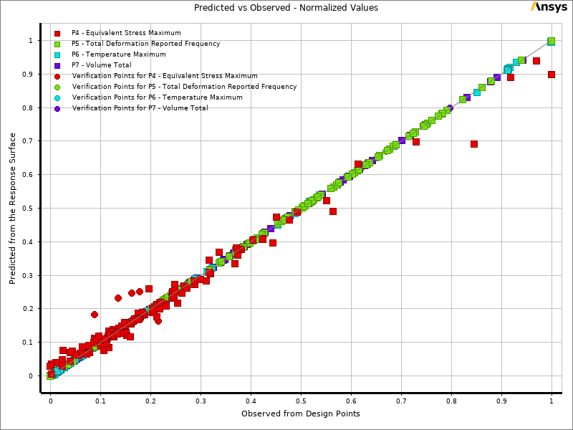

Figure : Goodness of fit

Table : Genetic Aggregation tolerances for response surface

|  |  |
| --- | --- |
| Objective | Tolerance |
| Equivalent Stress Max (MPa) | 3 |
| Total Deformation Reported Frequency (Hz) | 10 |
| Temperature Maximum (C) | 15 |
| Volume (m3) | 0.0001 |

The response surface created is then used in the optimization. I used the Multiple Objective Genetic Algorithm to find an optimum solution. The objectives were to minimize the volume and maximize the natural frequency. The other two parameters served as constraints. The maximum stress was to stay below 15 MPa and the temperature needed to stay below 550°C. These values would ensure that the brake would not fail. Literature states that brakes can experience over 515°C peak temperatures during use. The 550 limit is a good limit for this value for standard usage and operation. Three candidate points are picked by the program. These points are calculated based on the response surface so a verification by simulation is also run. After looking at the points, the values between the predicted and actual values are close enough to pick a design. I decided to pick Candidate point 1 which is outlined in table 3.

Table : Candidate point 1, solution for optimal design

|  |  |  |  |  |  |  |  |
| --- | --- | --- | --- | --- | --- | --- | --- |
| Point | Thick (mm) | OD (mm) | ID (mm) | Stress (MPa) | Freq (Hz) | Temp (C) | Volume (m3 |
| Cand 1 | 9.7723 | 123.97 | 77.026 | 14.522 | 1700.5 | 514.73 | 0.00050798 |
| Cand 1 (verified) | 13.209 | 1711.4 | 513.65 | 0.000508 |
| Reference | 25 | 125 | 75 | 12.556 | 2045.8 | 310.9 | 0.00099667 |

The major improvement is the volume of the new design. There is a 49.03% reduction in volume for the optimized design. This comes at the cost of 4.41% higher peak stress, 16.34% lower natural frequency and a 65.21% increase in max temp. It should be noted that all of these values are within the range of safe operation, so the increase of these other values is ok with respect to the volume. This design effectively serves its purpose while reducing the cost to produce it. This is not only an economic cost, but also an environmental cost as nearly twice as many brakes can be made with the same amount of material reducing the need for more steel mining and refining. Figure 3 shows the original design and the optimized design.

|  |  |
| --- | --- |
| Reference | Optimized |

Figure : Reference vs Optimized design of the brake

This design used the decrease in thickness as the primary method to reduce the volume of the brake. The brake calipers come up to the edge as well to ensure there is no wasted material on the other edges. The stress would obviously increase with the decreased overall surface area. This model also has less material so the same amount of energy would increase the temperature more. Overall, the results make sense with the change in the model.

# Conclusion

The model was successfully optimized to reduce the amount of material used while keeping the brakes operable and safe. The optimization took a long time and was more on the inefficient side of programs. This unfortunately is just the nature of an element wise design optimization. The speed and accuracy could be improved for both the response surface and optimization given a more powerful compute, a professional license for ANSYS, and more time. In an industrial setting, these extra resources would be highly cost effective as this method finds the best solution without needing to build many different models. There are some scoping issues with ANSYS that makes it difficult to complete the optimizations, but I believe that as time progresses, these issues will be worked out allowing for the software to become more robust.